Advanced Database Management Systems: Portfolio Final Report
Project Title: RichPay Fintech Database Engine

Author: Damilola Adetuyi

GitHub Repository Link: https://github.com/DamilolaAdetuyi-stack/advanced-database-portfolio

Executive Summary
The RichPay Fintech Platform is an enterprise-grade database solution designed to support secure, scalable, and high-performance financial transactions. This portfolio documents the complete lifecycle of the platform's data engine across five core areas: relational database design and normalization, query optimization, transactional concurrency control, NoSQL document integration, and cloud-distributed database architecture.

1. Relational Database Design and Normalization

Overview
For the core platform, I designed a relational database schema for RichPay, a digital banking application that manages user profiles, financial accounts, and transaction records.

Schema & Entity Relationships
The relational schema consists of three core entities:

- Customers: Stores user registration details, including full name, email, and contact details.

- Accounts: Tracks individual bank accounts linked to customers, holding current balances and account creation timestamps.

- Transactions: Logs money movements between accounts using dual foreign keys (sender_account_id and receiver_account_id).

Normalization
The database structure was designed from the ground up to satisfy 3rd Normal Form (3NF):

- 1NF: Column values are atomic (e.g., separating first_name and last_name).

- 2NF: All non-key attributes depend entirely on primary keys (customer_id, account_id, transaction_id).

- 3NF: Removed transitive dependencies so non-key attributes don't rely on other non-key columns.

Entity-Relationship Diagram (ERD)
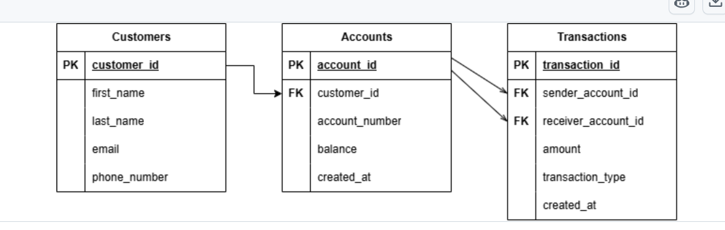
Below is the ER diagram showing table structures, primary keys, foreign keys, and 1-to-many relationship flows:

2. Query Processing and Optimization
Implementation & Testing Script To evaluate query execution behavior, I created queries.sql containing sample data and EXPLAIN ANALYZE commands:
EXPLAIN ANALYZE
EXPLAIN ANALYZE
SELECT * FROM Transactions WHERE sender_account_id = 1;
Execution Behavior & Optimization
- Unindexed Query: Without an index, the database performs a Sequential Scan (Seq Scan), checking every row in Transactions.

- Index Strategy: I added a B-Tree index on the foreign key column:
SQL CREATE INDEX idx_transactions_sender ON Transactions(sender_account_id);

);
- Optimized Execution: After indexing, EXPLAIN ANALYZE utilizes an Index Scan, lowering search complexity from $O(N)$ to $O(\log N)$.

SQL Script Reference Below is the committed queries.sql script containing data setup, indexing, and performance queries:
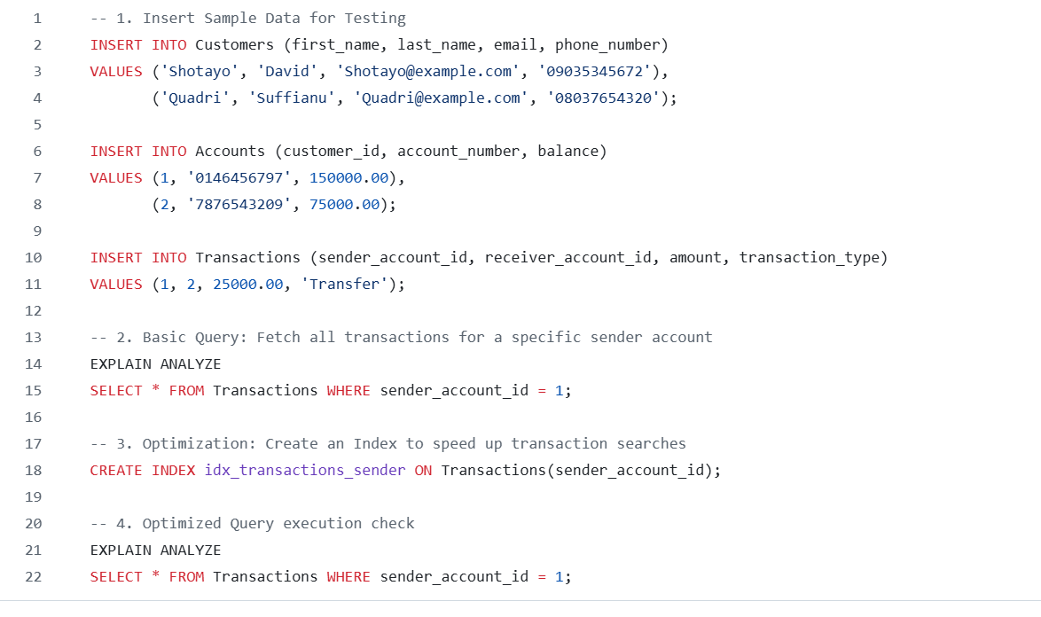

3. Transaction Management and Concurrency Control

ACID Integrity & Transfer Safety
Handling money requires strict atomic operations—a balance deduction and balance addition must succeed together or fail together. I wrote SQL scripts demonstrating COMMIT and ROLLBACK handling.

Implementation Scenarios
- Successful Transfer (COMMIT): Balance is safely deducted from Account 1, added to Account 2, and written to the audit log in a single transaction block.

- Failed Transfer (ROLLBACK): If an unexpected error or constraint violation occurs mid-transfer, executing ROLLBACK immediately reverses all changes, preserving account balances.

-- Transfer Example
BEGIN;
UPDATE Accounts SET balance = balance - 5000.00 WHERE account_id = 1;
UPDATE Accounts SET balance = balance + 5000.00 WHERE account_id = 2;
INSERT INTO Transactions (sender_account_id, receiver_account_id, amount, transaction_type)
VALUES (1, 2, 5000.00, 'Transfer');
COMMIT;
SQL

4. NoSQL Integration and Document Modeling

Relational vs. NoSQL
While SQL tables handle core financial ledger balances, a NoSQL document database (like MongoDB) is better suited for unstructured logs, security telemetry, and fast activity feeds.

Document Implementation
I designed a JSON document schema (nosql_model.json) that embeds sender/receiver names, transaction amounts, and flexible device metadata (e.g., IP address, device type, fraud check flags).

Storing device metadata in a NoSQL document avoids cluttering SQL tables with dynamic columns that change frequently across mobile app updates.

5. Distributed and Cloud Database Architecture

High Availability & Replication
To keep the application running 24/7 without downtime:

- Primary-Secondary Replication: The Primary node handles write queries (transfers), while secondary read replicas in different regions handle read traffic (balance checks and transaction histories).

- Automated Failover: If the main node fails, a secondary replica is promoted automatically.

Horizontal Scaling (Sharding)
The database uses customer_id as a Sharding Key to split user records and transaction histories across independent database nodes, preventing hardware bottlenecks as user sign-ups grow.

Conclusion
This project covers the full lifecycle of a database engine for a fintech application. By combining 3NF relational design, query indexing, ACID-compliant transaction blocks, NoSQL document logging, and cloud replication strategies, the platform guarantees data integrity, quick search queries, and high availability.

Declaration on the Use of Artificial Intelligence (AI)
In accordance with academic and professional integrity guidelines, I declare the use of AI tools during the completion of this database portfolio:

- Tool Used: Google Gemini (Large Language Model)

- Scope of Assistance:

  - Assisting with drawing layout checks and relationship syntax for the Draw.io ER diagram.

  - Formatting Markdown files, SQL script templates (schema.sql, queries.sql, transactions.sql), and JSON schemas.

  - Structural formatting and proofreading of documentation.

- My Contribution: All table attributes, schema constraints, project logic, repository commits, and final testing verification were reviewed, committed, and validated independently.

